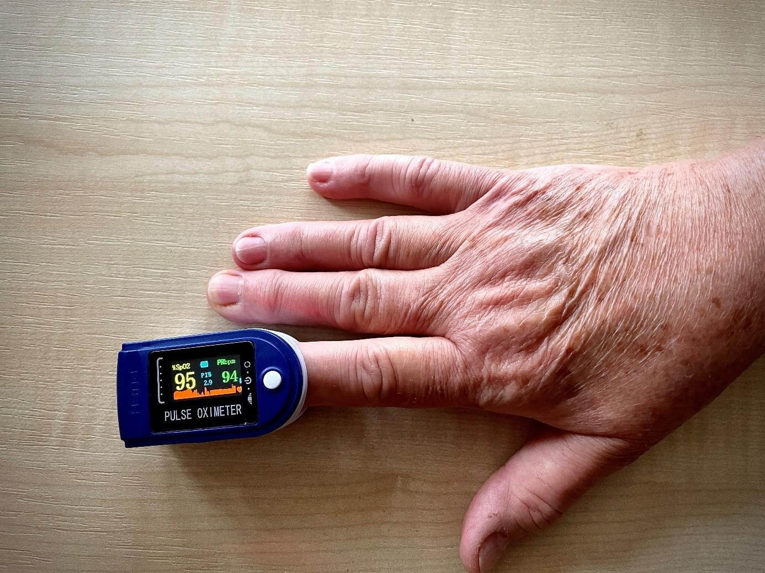
(Source: Central Transdanubian Regional Innovation Agency)

Do seniors cope with innovative technology?
Seniors and technology - two incompatible worlds. That seems to be the generally accepted idea. Is it really right?
To overcome a certain degree of reluctance of the elderly towards technological innovations, especially IT, seems to be a challenge. However, there are ways to overcome this hurdle, e.g. to involve the end-users in the design process of products and services from early on. This approach is called co-creation. During the last few months, several SMEs and public service providers in 6 European countries have tested this way of solution development in the homecare area and the received feedback shows that elderly mostly do accept IT solutions when being involved and supported as is shown in the following two examples.

Telemonitoring of physiological functions
One of the often-developed solutions for the homecare sector are devices and applications for remote monitoring of seniors. E-Med4All Europe Ltd., a Hungary based SME, designed such a solution which analyses the physiological functions of cardiovascular and autonomic nervous systems, and has a wide range of applications in medicine. The telemedicine system independently monitors over 30 physiological parameters by a simple oximeter, and sends the measured data to a processing unit in the cloud. Although most of the cardiovascular monitoring parameters offered by the SCN4ALL system were already known to science, their practical application, especially for the general population, was not yet solved.
Representatives of the SME were surprised how much the involvement of the elderly contributed to the product development. Although the work with seniors on the solution was time and energy consuming, it revealed many important features that the SME would not have thought of during the planning phase.
“The involved elderly were very positive about the process, enjoying the work and the fact that finally someone was very seriously interested in their opinions,” says István Hegedüs from the Central Transdanubian Regional Innovation Agency who also participated in the testing. He adds that “seniors are great to work with and their age is not really a disadvantage.”

Smart HomeCare system
In Slovenia, the SME called Caretronic tried to develop an innovative system with a similar concept which combines a touch-screen care phone, safety wristbands and smart pill dispensers to allow seniors to live longer and better at home and at the same time to provide their formal or informal caregivers with a tool for efficient care. The solution offers features such as emergency calls, notifications and reminders, care documentation, monitoring activity levels, detection of dangerous situations or automatic dispensing of medication in predefined time and doses.
Even though higher effort had to be made to motivate the elderly to participate due to the fact that activities were mostly taking place virtually for covid-19 reasons, eventually both SME and seniors appreciated the possibility to cooperate in the development process. Jelena Vidović from the Business support centre L.t.d., Kranj who participated in the process says that “the Silver generation definitely does not shy away from digital solutions, if they are properly introduced and used. Many of the seniors have digital skills. Key element is the right mixture of human contact and digital tools. Moreover, trust and regular communication are a must.”

“What we have learnt during the testing with our seniors is that the key to success and acceptance among end-users is doing your homework properly in learning what the real needs of your target group are. Ask the elderly what they want, have respect for their condition and capabilities,” says Lenka Hanušová from DEX Innovation Centre who is also taking part in the testing. “Be patient, explain everything thoroughly and involve the end-users in every step of the process.” adds Lenka Hanušová.

About HoCare2.0 project
The project supports the delivery and deployment of customer-centred home care solutions using the co-creation method. It is funded by the Interreg CENTRAL EUROPE Programme. The project is implemented by 11 partners from Czech Republic, Germany, Hungary, Italy, Poland and Slovenia.

About DEX Innovation Centre
DEX IC is a private innovation hub, the fastest growing in the country. It focuses on improving life and society through digital innovation, research and technology. DEX IC raises capital for innovative projects and products for the future in transport, energy, healthcare and ICT. It helps build startups and educates students and pupils. In its 10 years of existence, the DEX IC team has organized several of its own industry accelerators, runs a virtual incubator for start-ups and its own technology workshop, μFablab. DEX IC is a partner of the European initiatives EIT InnoEnergy and EIT Health.
Find out more here: https://dex-ic.com/

For more information, please, feel free to contact:
Lenka Hanušová | Communication Manager at DEX Innovation Centre
Phone: +420 603 167 624
E-mail: lenka.hanusova@dex-ic.com
https://dex-ic.com/

