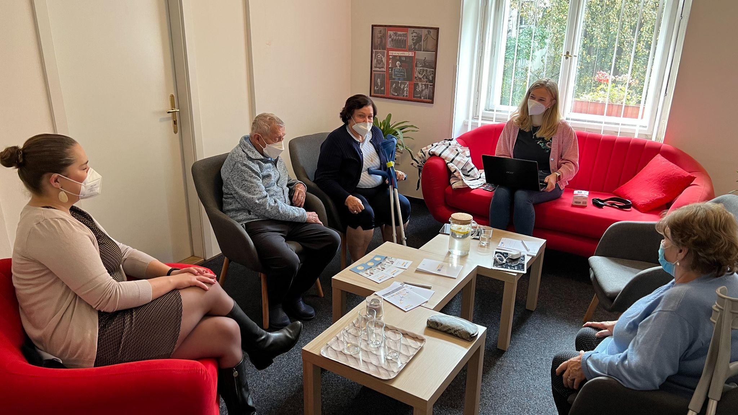

(Source: Institute for social services Prague 4)

Co-creation in homecare - a good match?

Ageing society and lack of professional carers drive the need for innovative products and services in the area of homecare. The challenge however is to deliver solutions which will be accepted by end-users. Co-creation is a promising method to tackle this issue as feedback from seniors is included in the design process from early on. Does it really help, though?

To get answers, 20 SMEs and Public service providers in 6 European countries took part in the HoCare2.0 project and tested the co-creation method in development of their own products and services. They were supported by Co-creation Labs - networks of relevant SMEs, Public service providers, researchers and end-users. Moreover, Tools were available to them with guidelines on how to approach co-creation with seniors effectively. All SMEs and Service providers eventually drew similar conclusions, such as in Italy and the Czech Republic.

**Easy access to clinical data**

In Italy, the company MEDnoTE developed an IT system for integrated use between specialists and home that allows the digitization and recording of clinical data and all home services. Through an access device - such as a tablet or smartphone or PC – the user or the caregiver talk to the doctor, in real time share clinical data such as vital parameters, results of blood tests performed at the patient's home. A key advantage is avoiding unnecessary trips to the hospital and increased level of serenity to the users and their caregivers, by knowing that the user is always monitored.

“The company representatives were positively impressed by the co-creation method. They appreciated the valuable feedback they received from participants which allowed them to improve the solution during the testing period,” says Matteo Donelli from the Cremona Chamber of Commerce who also participated in the testing. He adds that “the involved seniors appreciated most the feeling of protection and usefulness that the solution conveys”.

**The Social Ambulance**

The Institute for social services Prague 4 in Czech Republic developed an innovative public service during the pilot - the Social Ambulance. It is dedicated to providing complex help to the clients and their care-givers as a continuation of the „Centre for Family Care Providers”, already working within the Institute. The service includes social counselling, orientation in state support schemes, mediation and cooperation with registered social services or other facilities, psychological counselling, group activities (self-help group for caring), and palliative counselling.

Jan Schneider from the Institute for social services Prague 4 says that “having used the co-creation approach has led to improved care quality, e.g. by including modern technology in communication between clients and their loved ones during covid-19 lockdowns.” He adds that “the Institute is very satisfied with the jointly developed service and happy to see the positive impact on the clients and staff.”.

“Overall, feedback on using co-creation is only positive both from SMEs, Public service providers and from end-users,” says Lenka Hanušová from DEX Innovation Centre, who also took part in the testing. “The process might be demanding in terms of time, staff and coordination but it definitely pays off in the end. Moreover, there are the Co-creation Labs at hand with people to give advice and Tools that guide you through the process when needed,” adds Lenka Hanušová.

**About HoCare2.0 project**

The project supports the delivery and deployment of customer-centred home care solutions using the co-creation method. It is funded by the Interreg CENTRAL EUROPE Programme. The project is implemented by 11 partners from Czech Republic, Germany, Hungary, Italy, Poland and Slovenia.

**About DEX Innovation Centre**

**DEX IC** is a private innovation hub, the fastest growing in the country. It focuses on improving life and society through digital innovation, research and technology. DEX IC raises capital for innovative projects and products for the future in transport, energy, healthcare and ICT. It helps build startups and educates students and pupils. In its 10 years of existence, the DEX IC team has organized several of its own industry accelerators, runs a virtual incubator for start-ups and its own technology workshop, μFablab. DEX IC is a partner of the European initiatives EIT InnoEnergy and EIT Health.

Find out more here: <https://dex-ic.com/>

**For more information, please, feel free to contact:**

Lenka Hanušová | Communication Manager at DEX Innovation Centre

Phone: +420 603 167 624

E-mail: [lenka.hanusova@dex-ic.com](mailto:lenka.hanusova@dex-ic.com)

<https://dex-ic.com/>